AN IR PHOTONIC TYPE HLS SYSTEM DEVELOPED AT NSRRC

T.C. Tseng†, J. Wang, W.Y Lai, C.J Lin, K.H Hsu, D.G. Huang, C.S. Huang, C.K. Kuan, NSRRC, Hsinchu, Taiwan

Abstract

A simplified hydraulic levelling system (HLS) developing project has been carried out to monitor the ground settlement of TPS tunnel within 10 um resolution in these years. An IR photonic type integration was proposed to meet the requirement. This design consists of simple circuits with separated IR led and phototransistor to sense the water surface variation inside a small chamber installed on the ground. Through different sensing combinations assembled with several chamber types, a series of tests had been performed to examine the measurement range, linearity, resolution, etc. Eventually, an improved model consists of a chamber with three measuring cells is able to expand the sensing range to 10mm with 1um passible resolution. This system is under data communication test and will be manufactured next year. This paper presents the system design and testing results.

Introduction

Taiwan Photon Source (TPS) was successfully installed and commissioned at 2014 [1]. After a few years operation, the tunnel was found some local settlement areas form yearly survey works as shown in the Fig. 1. So two locally girder system adjustments were performed in 2020 & 2021 to correct this situation. However, the settlement phenomenon is mitigated or continued, we would like to have some levelling sensors to keep steadily monitoring except yearly survey in the long shut down period. Besides, there is no any settlement data in the beamline area since no survey schedule after installation.

FOGALE HLS (Hydraulic Level Sensor) is widely adopted in the synchrotron institutes to monitor the levelling deviation [2]. But we don’t have enough budget to establish the FOGALE system. A simplified and low cost HLS developing project has been carried out to monitor the ground settlement of TPS tunnel within 10 um resolution and at least 3mm range.

System Concept

During the construction of the VWM (Vibration Wire Method) magnet centring system, the photointerrupter sensor adapted to detect the variation of the wire is quite sensitive, reliable, simple and also cheap. Since a photointerrupter is the combination of an IR led & a phototransistor, the concept is to place one pair of isolated IR led & phototransistor aside of the water gap to transform the light intensity variation interfered by water level deviation to voltage variation.

From the study of the phototransistor circuit, there are common collector and common emitter two types of connection as in Fig. 2 [2]. When the phototransistor at common collector mode, it acts as a switch and the sensing range is narrow but high resolution as in the VWM system. When the phototransistor at common emitter mode, it acts as an amplifier and the sensing range is wide but lower resolution according to the applied voltage as in Fig. 3. Since the AD module can only read voltage less than 10V voltage, for 3mm levelling rage, 2~3 mV indicate 1um deviation is still detectable and also meet the requirement for 10um resolution.

Prototypes Testing

Templates are provided for recommended software and authors are advised to use them. Please consult the individual conference help pages if questions arise.

General Layout

Fonts

In order to produce good Adobe Acrobat PDF files, authors using the JACoW LaTeX template are asked to use only the fonts defined in the ‘jacow’ class file in standard, bold (i.e., \textbf) or italic (i.e., \textit) form and symbols from the standard set of fonts. In Word use only Symbol and, depending on your platform, Times or Times New Roman fonts in standard, bold or italic form.

The layout of the text on the page is illustrated in Fig. 1. Note that the paper’s title and the author list should be the width of the full page. Tables and figures may span the whole 170 mm page width, if desired (see Fig. 2), but if they span both columns, they should be placed at either the top or bottom of a page to ensure proper flow of the text (which should flow from top to bottom in each column).

Figure 1: Layout of papers.

Title and Author List

In order to optimize the system, there were five prototypes constructed and tested to establish a better one.

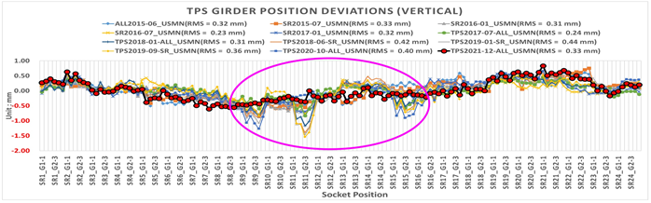

Figure 1: TPS girder position deviation from 2015~2021.

† email address : tctseng@nsrrc.org.tw

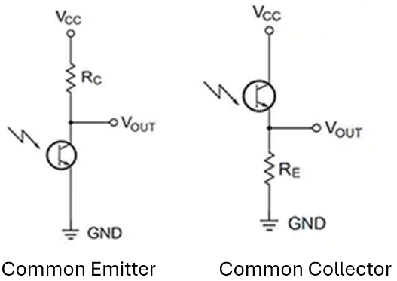

Figure 2 : Phototransistor circuit types.

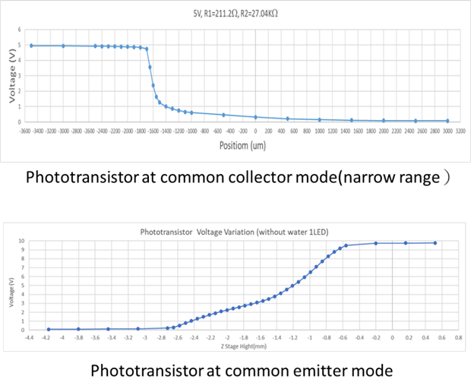

Figure 3: Phototransistor circuit types test results.

First prototype

This prototype was mad with anodized AL6061 as in Fig. 4. It consists of three pairs of led & phototransistor in one cell and two HLSs connected for testing. A combined linear corresponding curve was expected, but it was not easy to implement. Afterword, it is found that the voltage rage of phototransistor can be extend to 10V with one pair of IR set by adjusting the resister with the water surface floating over. However, due to the viscosity of the water restricts the short time repeatability and two HLS bodies connected with thin pipe seems not easy to maintain steady.[3]

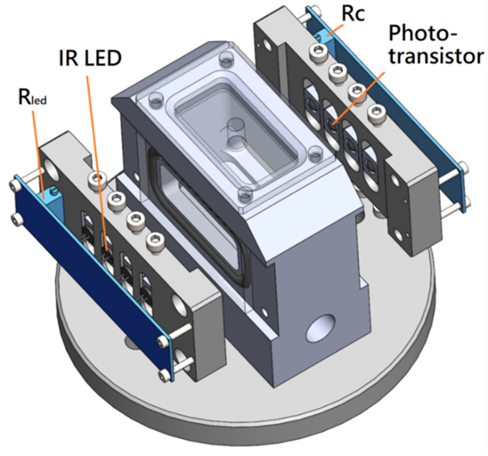

Figure 4: IR photonic HLS prototype 1

Second prototype

A plastic water pipe tank was setup as a buffer tank to maintain stability. Two Simple HLS Bodies with a single pair of led & phototransistor were fabricated for testing. One HLS moving with elevating stage, the other one to indicate the deviation of the buffer tank as a compensation as shown in Fig. 5 & 6. With this prototype system, a few IR sets were combined respectively for comparisons. Five led types：VISHAY-TSAL6200, VISHAY-VSLY5940, KODENSHI EL-23G, EVERLIGHT-IR333 & KODENSHI EL-1L7 were combined with three phototransistor types : KODENSHI-ST-2L2B, OSRAM-SFH313FA-2 & Everlight PT334-6B. Among These, TSAL6200 & IR333C combined with PT334-6B are better sets. The testing results shows that there is a most blocking situation as the water surface approach the top of led and phototransistor and the voltage range is extended. The sensing range is better than 5mm but a hysteresis phenomenon observed As in Fig. 7. Could the hysteresis phenomenon be decreased through long term operation is still unknown.

Figure 5: Testing system setup

Figure 6: IR photonic HLS prototype 2

Figure 7: Single cell prototype 2 testing result

Third prototype

Since the single cell prototype could reach 5mm sensing rage, a new prototype combined with three cells should extend the rage to 10mm with each pair 3mm apart in elevation as in Fig. 8. However, the testing result shows the sensing range is almost less than 3mm due to the racetrack shape cell or black anodized and a hysteresis phenomenon observed again as in Fig. 9.

Figure 8: 3 cells IR photonic HLS prototype 3

Figure 9: 3 cells prototype 3 testing result

Forth prototype

In the anodized aluminium alloy prototype testing, there were some corrosion scraps like small down feather found. May be the water was not clean enough. So a stainless HLS prototype with circle cell same as the single cell one was fabricate as in Fig. 9. The inside surface of cells in this prototype was first finely machined. But the testing results shows the sensing rage is almost less than 3mm and after then a sand blasted treatment was performed and the result is better but the hysteresis phenomenon is quite worse as in Fig.10 .

Figure 9: Stainless IR photonic HLS prototype 4

Figure 10: Sand blasted stainless IR photonic HLS prototype 4 testing result

Fifth prototype

Since there was worse hysteresis phenomenon of the stainless HLS prototype, another anodized Al5086 aluminium alloy prototype same as the stainless one was fabricated. The type alloy is mostly corrosion resisted. However, the testing result still shows worse hysteresis phenomenon but better than stainless one. Perhaps, the testing system has some problem after long time operation. Eventually, antifreeze was added to the water duct to reduce the viscosity or adhesivity as in Fig.11. The testing result shows anodized aluminium alloy HLS body has almost no hysteresis but the stainless one is still obvious though small than before as in Fig. 12 & 13. There is still obvious hysteresis phenomenon of PT3 may be due to the large travelling of stage or interference between two HLS, need to further investigate.

Another stability resuming & resolution tests shows that a sudden shake of the water tank takes 4 minutes to resume roughly stable and 5 um stage moving is detectable as in Fig. 14.

Figure 11: Layout of papers.

Figure 12: Anodized AL5086 IR photonic HLS prototype 5 testing result with antifreeze added

Figure 13: Stainless IR photonic HLS prototype 4 testing result with antifreeze added

Figure 14: Anodized AL5086 IR photonic HLS 5 um steps testing

HLS system integration

In the testing system, an NI-PCIe6320 AD/DA card for signal processing. Two types of Ethernet AD module ADAM-6017 & ADAM-6117EI from Advantech [4] are investigated for onsite installation. With a simple power supply, the cost of each IR HLS system should be less than 1,000 USD (30,000 NTD)

CONCLUSION

A simplified & low-cost IR photonic Hydraulic Level Sensor (HLS) system by sensing the water surface floating is developed & tested. The anodized aluminium alloy HLS shows better condition than stainless one with antifreeze added in the water duct. The sensing range of one cell system can be better than 5mm. HLS with three cells can be combined to extend the sensing range to 10mm. The resolution can be better than 5um. However, The hysteresis phenomenon still need to be investigated to improve the accuracy.

References

[1] NSRRC, http://www.nsrrc.org.tw

[2] Pster in IWAA 2022

[3] Bill Schweber, “how to use photodiodes and phototransistors most effectively”

[4] Advantech, http://www. advantech.com